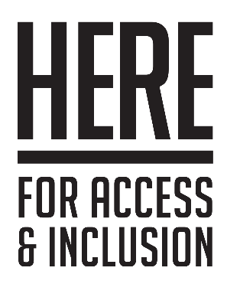

**Access Rider**

## What is an Access Rider?

* An Access Rider is a document that details your individual access requirements.
* Anyone can use an Access Rider to make sure any reasonable adjustments they need to perform a job are taken into consideration from the beginning.
* Using an Access Rider helps individuals and organisations (like a gallery or events team) feel comfortable and sure about working together.
* Once you have completed your Access Rider, you can take it to any venues and organisations you work with.

## What is in this Access Rider?

The Access Rider has 4 parts:

1. Your details: name, job or role, and contact information.
2. Your access requirements: what adjustments you want during your job or role.
3. Emergency information: what we need to know about you in case of an emergency.
4. Further information: any other relevant information you want to share.

## Who will see the information in your Access Rider?

* Any organisation you share your Access Riderwith should **only** share it with the people responsible for supporting and managing you in your role.
* Organisations should not share this document with anyone else without your permission.

# Your Access Rider

## Your Information:

Name:

Job or role:

Phone number:

Email address:

## Your access requirements:

* Tell us about your access requirements.
* We have given some examples of areas you might like to talk about. You can add other areas if you want to.
* You can talk about your disability, but you do not have to. You can just tell us what ways we can help you.
* You should only include information about things that are relevant to your work, and what you need to do your work.

## Communication:

## Information:

## Travel:

## Meetings:

## Events:

## Costs:

## Other:

# Emergency Information

* Use this section to tell us what to do in an emergency.
* You can also provide your emergency contact person.

# Further Information

* Give us any other information or resources you think will help us to understand you.

# Further Guidance

University of Atypical is a disabled-led organisation that supports and promotes work by d/Deaf, disabled, and neurodivergent artists.

If you require more information, University of Atypical may be able to provide you with guidance, or direct you to further resources. You can learn more by visiting the [University of Atypical website](http://universityofatypical.org).