DCSDC PEACEPLUS Local Co-Designed Action Plan – E Newsletter Summer 2024
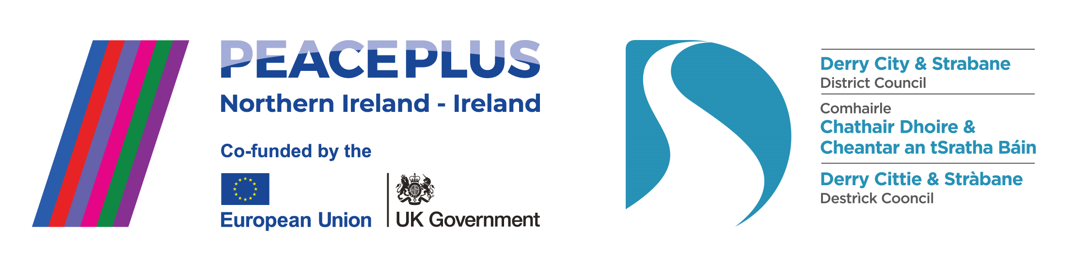

The PEACEPLUS Programme is a funding partnership between the European Union, the Governments of the United Kingdom and Ireland, and the Northern Ireland Executive and will be administered by the Special EU Programmes Body (SEUPB).

Lift Off! PEACEPLUS Local Co-Designed Action Plan officially launched 6th June 2024.



Council and Communities celebrate launch of £8 million PEACEPLUS programme.

Derry City and Strabane District Council and the PEACEPLUS Partnership Board have officially launched an £8,047,327 (€9,254,427) funded programme. The Local Co-Designed Action Plan, developed through an intensive co-design process in partnership with local communities, will fund 58 council area projects. The Local Co-Designed Action Plan is a project supported by PEACEPLUS, a programme managed by the Special EU Programmes Body (SEUPB).

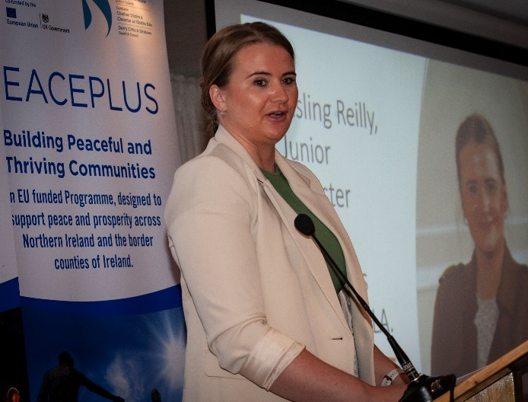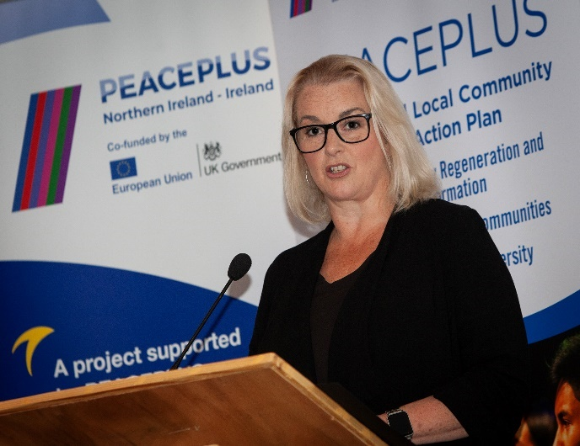

Speaking at the launch, Executive Office Junior Minister Pam Cameron said:
“It is heartening to know this new action plan will support a wide range of initiatives aimed at promoting reconciliation, building trust and fostering greater understanding between communities. This is another step towards a more peaceful and prosperous society, and I’d like to thank everyone who will see the plan through from its inception to conclusion, from council staff to delivery partners and the many participants who are doing so much to foster good relations and build a brighter future for us all.”

Executive Office Junior Minister Aisling Reilly said:
“At its core, this action plan is about empowering local communities to take ownership of peace and reconciliation, and to drive positive change from the ground up. It reflects the voices, aspirations and priorities of the people who know this community best – the people who live and work here every day. This new plan is an opportunity to build on the significant progress that has been made over the years and to create a more resilient, cohesive and vibrant society for future generations.”

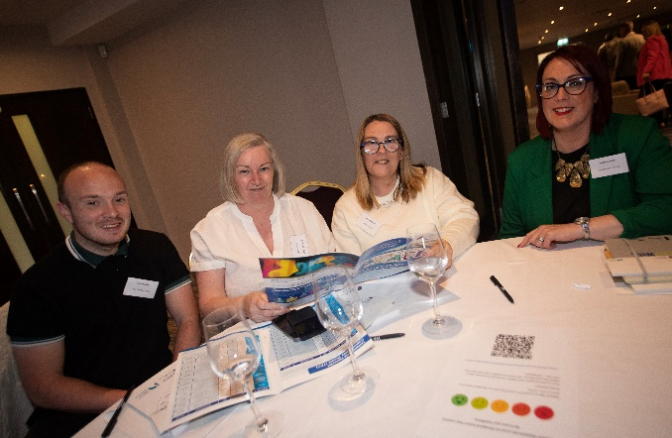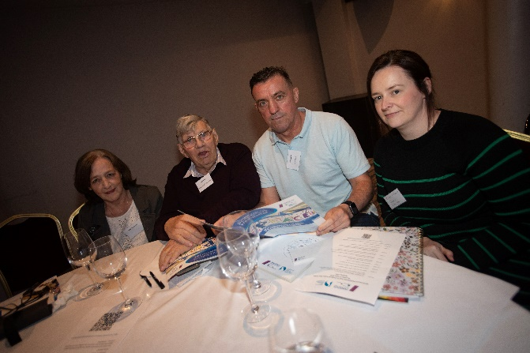

Minister of State at the Department of Rural and Community Development, Joe O’Brien TD said:
“I would like to congratulate everyone who contributed in any way to the development of the Derry City and Strabane District Council PEACEPLUS Local Co-Designed Action Plan, which recently secured funding of over €9.25m under the European Union’s PEACEPLUS programme.

“I commend Derry City and Strabane District Council and the PEACEPLUS Partnership that will oversee the development and delivery of this Action Plan. I am confident that the 58 localised community relations projects supported in this plan will result in purposeful, meaningful and sustained contact with others from different community, cultural and political backgrounds.

“I'm happy that my Department of Rural and Community Development, working with the Special EU Programmes Body and the Executive Office in Northern Ireland, will be able to support and fund this fantastic Action Plan to ensure its successful implementation, which will have a long-term and beneficial impact on the region.”

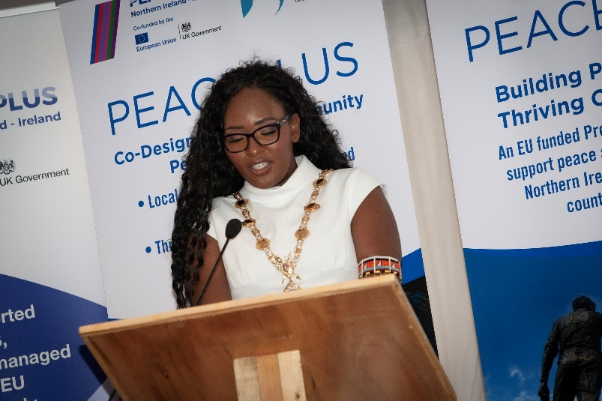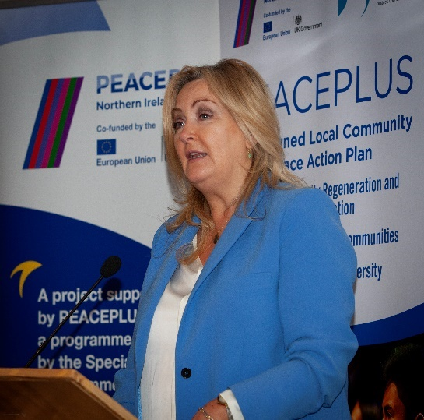

Speaking at the launch, SEUPB CEO Gina McIntyre, said
“I am very pleased to be here today to celebrate the launch of Derry City and Strabane District Council’s Local Co-Designed Action Plan. The Council’s programme, which was one of the first to be approved under PEACEPLUS Investment Area 1.1, reflects the legitimate and meaningful engagement which has taken place at local level. The 58 projects and initiatives that will be delivered under this programme are immensely exciting and diverse; and demonstrate the wide variety of ways in which the funding will be utilized to empower community connections and promote inclusivity, peace and reconciliation across the council area.”

Mayor of Derry City and Strabane District Council Cllr Lilian Seenoi spoke at the event. Welcoming the launch, she said:
“As mayor, and as a member of the PEACE Board, I know the intensive co-design process which council and communities invested to reach this point. Today is ‘lift off’ for starting to roll out much needed peace and reconciliation funding to benefit local people and communities across our city and district. From Castlederg to Caw, Strathfoyle to Strabane, Creggan to Claudy we hope this programme will engage and bring together our diverse communities for the benefit of all.’

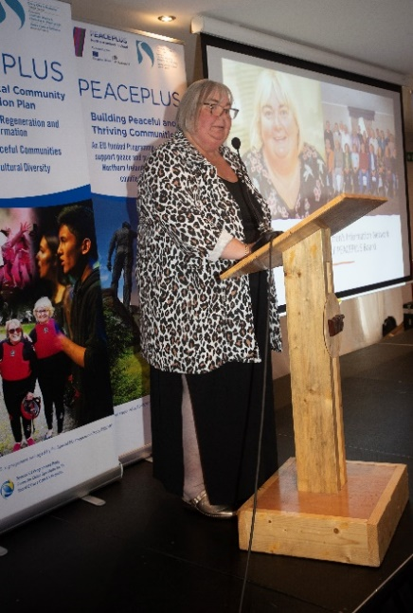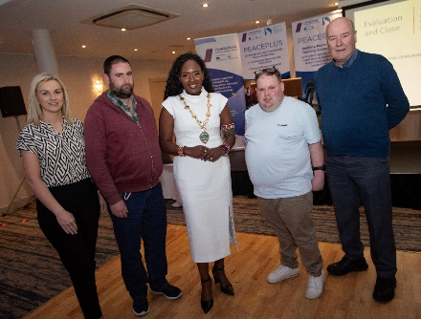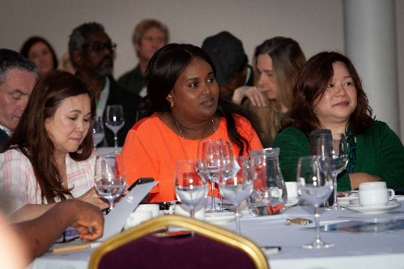

Catherine Cooke (Foyle Women’s Information Network / Chair of the PEACEPLUS Board.) said:
“Today’s launch marks a huge milestone. The 58 tendered projects in the Co-Designed Local Action Plan will pour vital funding into local communities. Partnership working has brought us to this point and successful delivery will require groups to continue to work together. All the projects are cross-community in nature and aim to be ‘transformative’ to participants in building awareness of and respect for diversity and inclusion. All projects will be provided free to participants and the overall programme has been co-designed to be inclusive of key identities including different genders, ages, those impacted by the legacy of the past, Black and Minority Ethnic identities, disability, religion and sexual orientation.”

Martin Duffy (Derg Local Growth Partnership / Co-Chair of the PEACEPLUS Board) added: “Amongst the 58 projects is something for everyone - active environmentalism, cricket, outdoor pursuits, history, heritage, upcycling, music, dance, Irish language, farming, street art and much more. Whilst our programme is not strongly focused on capital works, we’re delighted to have included physical and shared space work around Park Community Hall, an Intercultural Café, a Food Poverty Kitchen and World War Memorials. There are also key projects offering community and voluntary sector training and volunteering opportunities, youth inclusion projects in rural and urban areas and projects empowering interface residents.”

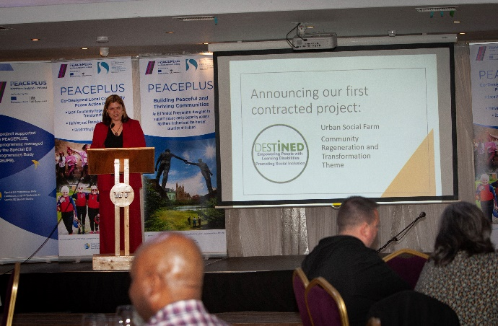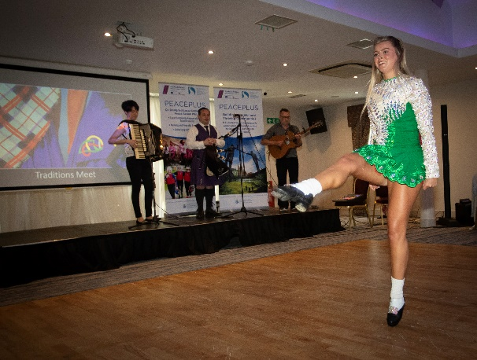

Sue Divin is Derry City and Strabane District Council’s PEACE Manager encouraged local community groups to look at the opportunities and tender to win the contracts. “As well as the programme being launched today, we’d encourage groups to watch out for the Theme 1.2 Small Grants opportunities up to €100,000. These are separate to council’s programme so groups should watch for those opportunities on the SEUPB website and social media.”

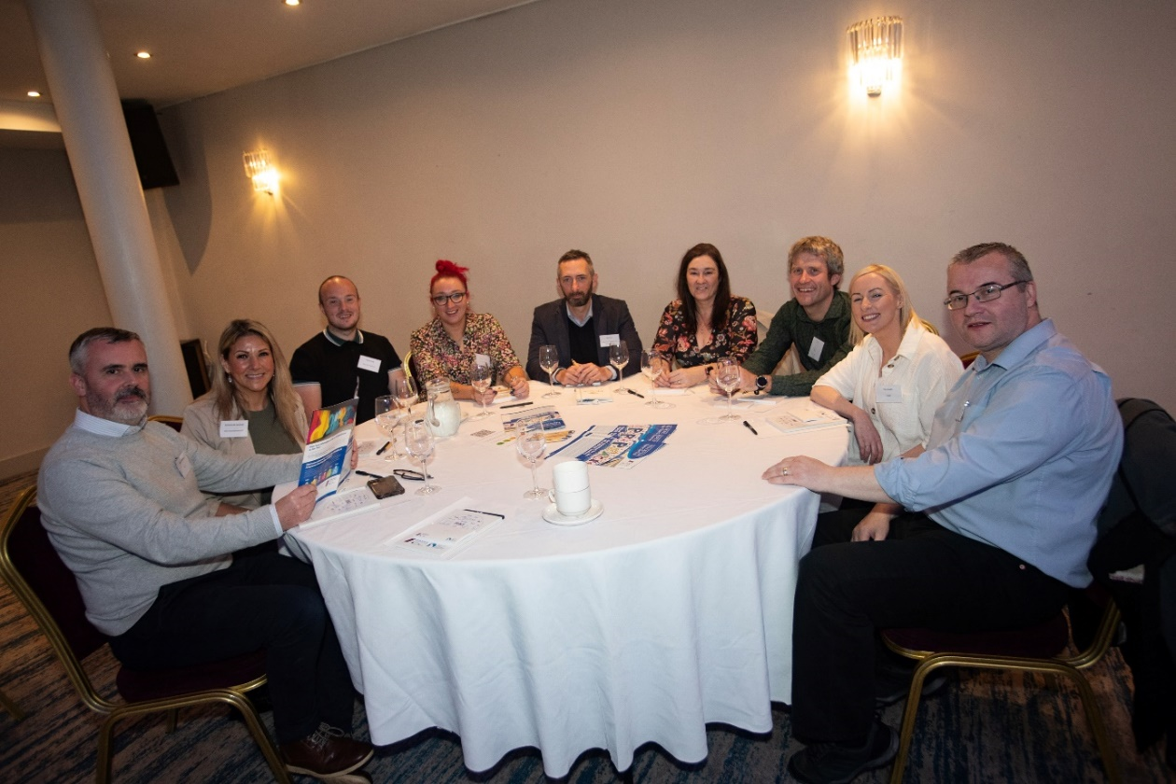

Update on contracts for tenders already issued.
Now that the funding is formally in place, the PEACE Team are working their way through letters informing groups of outcomes of projects, pre-contract checks and issuing of contracts. Many successful groups will now be in this process. Tenders which closed in June should hear in August the outcome of their tenders.

Soon to be live tenders under DCSDC PEACEPLUS Local Co-Designed Action Plan:

Tender | Deadline for Returns
T24-109BUS PEACEPLUS Theme 1.1 IDEA (Intergenerational Dialogue Engaging Arts). Re-issue | See e-tenders
T24-110BUS PEACEPLUS Theme 1.1 Out and About (BAME). Re-issue | See e-tenders
T24-111BUS PEACEPLUS Theme 1.1 Our Journey to Peace. Re-issue | See e-tenders

All the rest will follow from early Autumn onwards!

Future tenders and public tender training workshop.

It is anticipated that all remaining tenders not yet advertised will be advertised via e-tenders in the early Autumn. Groups interested in tendering for these are strongly encouraged to attend the tender training workshop for 2pm, Tuesday 3rd September in St.Columb’s Park House. Advance registration and details are on Eventbrite here:

https://www.eventbrite.co.uk/e/communitypublic-tender-training-for-dcsdc-peaceplus-theme-11-action-plan-tickets-939510720857?aff=erelexpmlt

Venue: St.Columb’s Park House (Main Hall), Limavady Road, Waterside.
Date: Tuesday 3rd September
Time: 2pm – 4.30pm (Tea/Coffee available from 1.45pm)

Council Website announcement: https://www.derrystrabane.com/business/tenders
All tenders are on E-Tenders NI: https://etendersni.gov.uk/epps/home.do
All our tenders are public procurement processes. Any organisations wishing to tender should do so via E-Tenders NI.

Want information on the projects / tender opportunities (including order of advertisement)?

Download a user-friendly version of our Local Co-Designed Action Plan Here:
https://www.derrystrabane.com/community/peace-plus/co-designed-action-plan

Download a more detailed project overview of the 58 included projects here:
https://www.derrystrabane.com/community/peace-plus/co-designed-action-plan

For email updates on tendering opportunities, see our website and make sure you’ve signed up to our email newsletter: https://www.derrystrabane.com/community/peace-plus

Don’t miss out on wider PEACEPLUS funding opportunities!
Remember, council doesn’t ‘run’ all of PEACEPLUS. Groups can apply directly to SEUPB.
Sign up to SEUPB’s emailing list here: https://seupb.us7.list-manage.com/subscribe

SEUPB €100,000 Small Grants Opportunity.
SEUPB have indicated they will issue a Small Grants Programme under Theme 1.2. Groups will be able to apply for up to €100,000. This is anticipated by early Autumn. https://www.seupb.eu/PEACEPLUS

Grantfinder.
Check out other funding options on Grantfinder: https://search.mygrantfinder.co.uk/

Contact us:
The Peace Team in council can be reached via peace@derrystrabane.com
Our website is: https://www.derrystrabane.com/community/peace-plus

The PEACEPLUS Programme is a funding partnership between the European Union, the Governments of the United Kingdom and Ireland, and the Northern Ireland Executive and will be administered by the Special EU Programmes Body (SEUPB). Match-funding for this element of the PEACEPLUS Programme has been provided by the Executive Office in Northern Ireland and the Department of Housing, Planning, Community and Local Government in Ireland.

