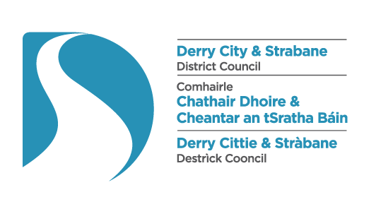

**STRABANE TOWN CENTRE   
PUBLIC REALM IMPROVEMENTS FEEDBACK FORM**

We would appreciate it if you could take the time to provide feedback on the proposals presented on the accompanying displays.

**Q.1: THE PRINCIPLE**

Do you support the principle of a public realm scheme that will improve the following streets in your area; Abercorn Square, Part of Upper Main Street, Market Street, Railway Street, Derry Road Strabane.

YES NO

**Q.2: ISSUES**

Do you have concerns about the existing public realm in your area that needs to be addressed as part of the proposed Strabane Town Centre Public Realm Scheme? (Please tick one)



YES NO

Are there any current issues that you wish to comment on?

*Please provide comments below:*

**Q.3: THE DESIGN PROPOSALS**

Do you agree that the emerging public realm design proposals will have a positive impact on the quality of the environment in Strabane Town Centre and Railway Street? (Please tick one)



YES NO

Are there any aspects of the design that you wish to comment on?

*Please provide comments below:*

**Feedback Form Continues On Reverse.**

**Q.5: COMMUNITY CONSULTATION**

Do you feel the Pre-Application Community Consultation (PACC) process has enhanced your understanding of the Strabane Town Centre Public Realm Improvements Project? (Please tick one)

YES NO

*If No, please provide any additional comments below*:

**Q.6: OTHER MATTERS**

Please outline any other issues, ideas or views on the proposed redevelopment of Strabane Town Centre.

………………………………………………………………………………………………………………………...

Name: …………………………………………………………………………………………………………………

Address: ………………………………………………………………………………………………………………

E-Mail: ………………………………………………………………………………………………………………..

**Please return the questionnaire in the box provided**

**Please ensure that all feedback forms are received before 31st January 2025**

***Note:*** *Any comments you make to us during this process are not representations to the planning authority and do not in any way affect your statutory right to make representations to the planning authority with regard to any application submitted to them in respect of this proposal.*

**Email Returns:** [strabanepublicrealm@derrystrabane.com](mailto:strabanepublicrealm@derrystrabane.com)

**Postal Returns:** Strabane Public Realm  
 Derry City and Strabane District Council  
 Environment and Regeneration Directorate  
 98 Strand Road  
 Derry  
 BT48 7NN