SAP 2009 software supplement (Technical Booklet F1 June 2022)
This supplement can help demonstrate compliance with regulation 43B and 39 (Technical Booklet F1 paragraph 2.17 to 2.22, 2.41 & 2.48, ) using the Government’s Standard Assessment Procedure (SAP) for Energy Rating of Dwellings SAP 2009 software
Betterment over the target emissions rate TER from SAP 2009 software
(40% for houses & 25% for flats (Paragraph 0.7)
TER less Betterment % ______ - ____ % =______
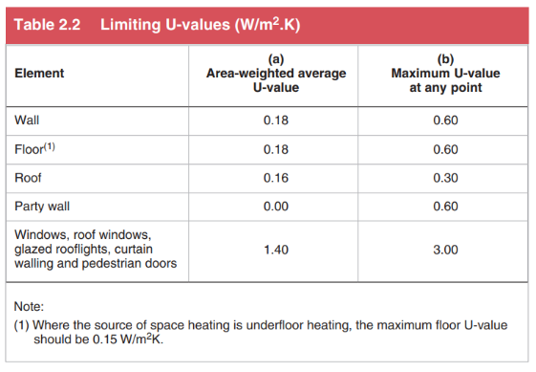
limits on building fabric performance.
Limiting maximum U-value
Are the U-values for each of the elements no greater than limiting U-values (See Table 2.2) Yes / No ?
Limiting extent of openings
Total area of openings ____ m2
Ratio openings to floor____ %
Doors & glazing openings no greater than 25% of the floor area Yes / No ?
Where answering no to either of above, a whole building area weighted U-value calculation will be required (Paragraph 2.44)
Renewable generating technologies
Are renewable generation technologies proposed to produce electricity Yes / No ?
If answering yes then complete the following:
- Confirm proposed type of connection to Northern Ireland Electricity Networks – export / non-export?
- For an export connection is a formal NIE connection offer available
Yes / No ?
- For a non-export connection has evidence of compliance been provided at plans application stage (Paragraphs 2.20 and 2.21)
Yes / No ?
- Applicants and designer are aware that at completion stage formal confirmation will be required that an export connection has been provided or a report demonstrating compliance with a non-export connection will be required.
Yes / No ?

