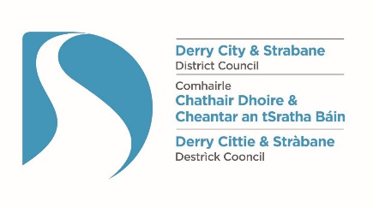
The Street Trading Act (Northern Ireland) 2001

Guidance on applying for a Stationary Street Trading Licence

*** PLEASE READ THE FOLLOWING IMPORTANT INFORMATION ***

Applications for stationary street trading licences must be received by Derry City and Strabane District Council within the following time scales:

Type of application | Deadline for receipt of completed application
Grant | 8 weeks prior to the proposed date of trading
Renewal | 4 weeks prior to the expiry date of the current licence

Stationary Licences can only be granted for streets which have been designated as being suitable for stationary street traders. Please refer to the current list of designated streets.

Stationary traders operating more than one stall will require separate licences for each one and a separate application is required for each licence.

The application form must be completed fully, in BLOCK LETTERS, using BLACK INK.

Completed application forms must be accompanied by the relevant fee(s) and charges. Cheques must be made payable to Derry City and Strabane District Council. Card payments can also be made over the telephone. Cash should not be sent in the post.

The completed application form must also be accompanied by the following:

- one colour, full face, passport size photograph of the applicant

- an AccessNI Basic Disclosure Certificate, which is not more than 12 months old at the time of the application. Information on how to obtain a certificate is available at https://www.nidirect.gov.uk/campaigns/accessni-criminal-record-checks. Applicants from outside Northern Ireland should contact the Licensing Section for advice on Criminal Records checks (contact details below)

- written permission from the landowner or lessee where the application relates to trading on private land

Please note: Traders may be required to submit additional documentation and / or certificates prior to trading, as a condition of any licence granted.

Completed application forms, plus relevant fee and other enclosures, must be returned for the attention of the Licensing Section at either of the following addresses:

Derry City and Strabane District Council  98 Strand Road  Derry  BT48 7NN | Derry City and Strabane District Council  47 Derry Road  Strabane  BT82 8DY

If you require any assistance in completing your application the Licensing Section will be pleased to assist you.

We can be contacted:
- by telephone 028 71 253 253; and/or
- by email: licensing@derrystrabane.com

Privacy Notice
Data Controller Name: Health & Community Well Being Department/Licensing Derry City & Strabane District Council
Address: 98 Strand Road, Derry, BT48 7NN
Telephone: 02871 253253 Email: licensing@derrystrabane.com

Data Protection Officer Name: Damian McCay
Telephone: 02871 253253 Email: Damian.McCay@derrystrabane.com

Why are you processing my personal information?
- For the logging, processing and determination of licensing/permit applications.
What categories of personal data are you processing?
- Personal contact details
Where do you get my personal data from?
- Application Forms and accompanying documents
Do you share my personal data with anyone else?
- Yes, where required by legislation we may share personal date with other agencies as outlined on Council website at the following link http://www.derrystrabane.com/Footer/Privacy-Policy
Do you transfer my personal data to other countries?
No
How long do you keep my personal data?
We will only retain your data for as long as necessary to process your application or investigate an Enforcement case, and in line with Council’s Retention and Disposal Schedule.

What rights do I have?
- You have the right to obtain confirmation that your data is being processed, and access to your personal data
- You are entitled to have personal data rectified if it is inaccurate or incomplete
- You have a right to have personal data erased and to prevent processing, in specific circumstances
- You have the right to ‘block’ or suppress processing of personal data, in specific circumstances
- You have the right to data portability, in specific circumstances
- You have the right to object to the processing of your data, in specific circumstances
- You have rights in relation to automated decision making and profiling

You should refer to the Council’s website for further information on your rights: http://www.derrystrabane.com/Footer/Privacy-Policy

How do I complain if I am not happy?
If you are unhappy with how any aspect of this privacy notice, or how your personal information is being processed, please contact our Data Protection Officer.

If you are still not happy, you have the right to lodge a complaint with the Information Commissioner’s Office (ICO):

Information Commissioner’s Office
Wycliffe House, Water Lane, Wilmslow, Cheshire, SK9 5AF

Tel: 0303 123 1113 Email: casework@ico.org.uk https://ico.org.uk/global/contact-us/

Street Trading Act (Northern Ireland) 2001
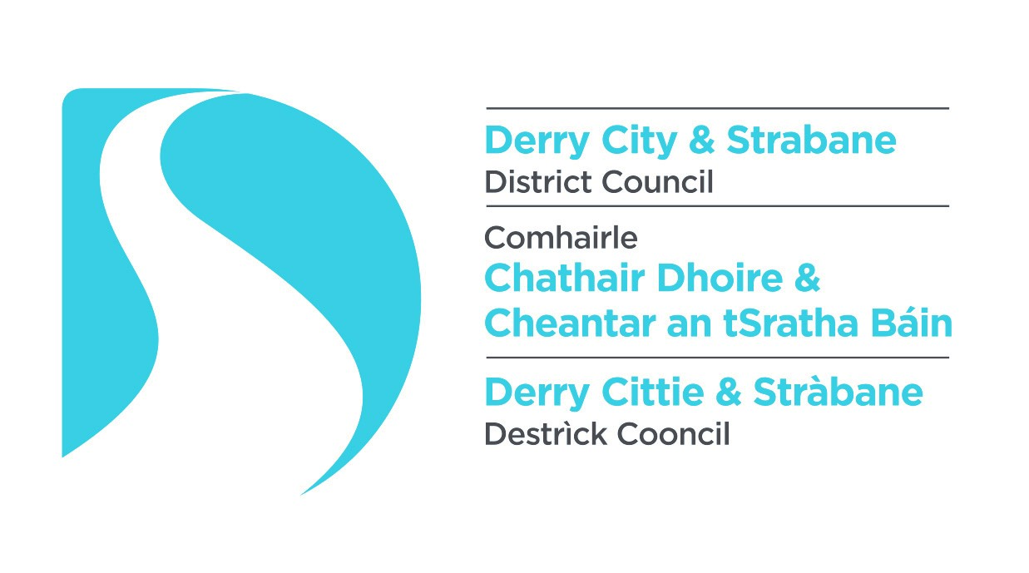
Application for a Stationary Street Trading Licence

For Office Use Only
Date application received
Fees / documentation
Appropriate fee / charges |  | Criminal records check |  |  | Site / location plan
Passport photo of applicant |  | Photographs of receptacle |  |  | Written permission from the landowner

*Please tick appropriate boxes ()
1. Type of application
Grant* |  |  | Renewal*

2. Full name of applicant
Title: (e.g. Mr/Mrs/Miss)

Surname:

First name(s):

Previous name(s):

3. Contact details
Current home address:
Address:

Post code:

Previous home addresses (within last 5 years):
(continue on separate sheet if necessary)
Address:

Post code:

Business address (if different to home address)
Address:

Post code:

Telephone numbers
Home:

Business:

Mobile:

E-mail:

4. Personal details
Date of birth:

National insurance number:

5. Description of articles, things or services in which you wish to trade:

6. Description of receptacle to be used:
Type of receptacle (e.g. stall, vehicle, trailer, hand cart, etc.):

Vehicle registration number (if vehicle or trailer):

Maximum footprint dimensions of receptacle: (including any overhanging awning, outward opening doors, etc.)

Length (m) |  | Width (m)

7. Ownership of receptacle to be used:
Do you own the receptacle? | Yes* |  |  | No*

If “no”, what are the contact details of the owner?
Name:

Address:

Post code:

8. Address where receptacle will be kept when not in use:
Address

Post code

9. Address where articles / things for sale will be stored:
Address:

Post code:

10. Proposed trading dates / days / times:
Date range:
From: |  | To:

Trading day(s):* |  |  | Trading hours:
 |  |  | From: | …until:
Monday
Tuesday
Wednesday
Thursday
Friday
Saturday
Sunday

11. Proposed stationary trading site or location:
Requested trading position

Name of street / road / public place:

Exact location:

Please note: a stationary street trading licence can only be issued if the requested trading position is in a street which has been designated as being suitable for stationary street traders within the district. Please refer to the current list of designated streets.

Permission to use land

Is the trading position located on privately owned land? | Yes |  | No

If the trading position is located on private land please provide contact details of the owner / person in control of the site:

Name:

Address:

Post code:

Telephone:

If you are applying to trade from a position located on private land, you must provide written evidence of permission from the landowner to trade at that site at the time of application.

12. Additional relevant information:
If the goods/ services supplied include food, are you registered as a food business? | Yes* |  |  | No*
If yes, please provide details (i.e. name of Local Authority where registered, the current food hygiene rating and the date awarded):

Local Authority:

Current Food Hygiene Rating: |  | Date awarded:

Will bottled, liquefied petroleum gas (LPG) be used? | Yes* |  |  | No*

Will an electrical generator be used for power? | Yes* |  |  | No*

Type of generator: | Petrol* |  | Diesel* |  | LPG*

Have you previously held or do you currently hold a street trading licence? | Yes* |  |  | No*

If yes, please provide details:
Type of licence: | Council issuing the licence: | Date of issue: | Date of expiry:

Have you ever applied for and been refused a licence? |  |  | Yes* |  |  |  | No*
 | If yes, please provide details:
 | Type of licence applied for: | Council refusing the licence: |  |  | Date of refusal:

Do you have public liability insurance? |  |  |  | Yes* |  |  |  | No*
 | If yes, please provide details:
 | Insurance Company: | Policy Number: | Next renewal date: |  |  | Amount of cover:

13. Declaration:
I hereby apply to Derry City and Strabane District Council for the grant of a Stationary Street Trading Licence.

I understand that if I have made a statement, which I know to be false in a material particular, my application may be refused or any licence granted as a result of this application may be revoked.

SIGNED: |  | DATE:
(N.B. If you make a statement which you know to be false in connection with this application you will be guilty of an offence and liable, on conviction, to a fine not exceeding £1000.)

