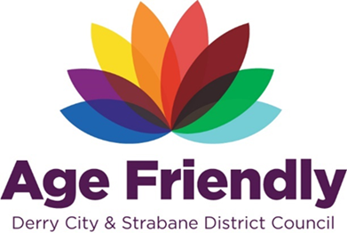

AGE FRIENDLY NEWS & UPDATES
Edition 58 – 26/06/24

- Positive Ageing Month Open call
- Information session for professionals on financial supports for people with cancer and their carers
- Monthly meeting for people diagnosis of dementia
- Brain health event
- Jobstart scheme
- Vulnerability and Carbon Monoxide Allowance (VCMA) Annual Showcase

- POSITIVE AGEING MONTH OPEN CALL

As people live longer, we all need to consider how best to support the older generation in our community – but also how best to celebrate them. Each year, during the month of October, Positive Ageing Month is held, which offers opportunities for a range of events, activities and programmes to be held which celebrate the contribution older people make to their communities. The theme for this year’s PAM is:
‘Celebrating roles older people play and can play in the Communities’
Derry City & Strabane District Council, alongside the Western Health & Social Care Trust and the Public Health Agency are gearing up for Positive Ageing Month this October and are encouraging various groups and organisations to get involved as part of Positive Ageing Month. Please see attached an event template for completion for a one off event or recurring events that you are holding within your organisation/community setting that you would like to be included in the Positive Aging Month brochure. Closing date for returns is Tuesday 16th July and please send completed form back via email to agefriendly@derrystrabane.com
Please also include a high resolution photo or logo to accompany your information.
Please circulate to anyone that you think this may be of interest to.

2.0 INFORMATION SESSION FOR PROFESSIONALS ON FINANCIAL SUPPORTS FOR PEOPLE WITH CANCER AND THEIR CARERS

You are invited to a short online information session for professionals working with people with a cancer diagnosis and their carers on financial supports. The session takes place as follows:
Date: Friday 28th June 2024
Time: 9.15am – 10.15am
Teams link: Join the meeting now
Meeting ID: 315 389 748 414
Passcode: fg2VKs
Liz Kennedy, Macmillan Welfare Benefits Co-ordinator will provide a brief overview of the Macmillan Welfare Benefits Service including information on how to refer, eligibility for referral, how the Welfare Benefits Service can support people with cancer and their carers and updated information on recent changes to Macmillan grants.
Martha Magee, Macmillan Information & Support Manager will outline the additional support her service provides around financial wellbeing including grants available through other regional charities and supports Macmillan offer around financial planning and wills.
Please share with colleagues who may be interested in attending.

- MONTHLY MEETING FOR PEOPLE DIAGNOSIS OF DEMENTIA

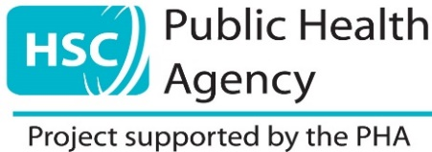

We would like to invite you to our monthly information / activity sessions for people with a diagnosis of dementia along with their family and carers.

The monthly events will be held in St Columb’s Park House
4 Limavady Road, Waterside, Derry / Londonderry BT47 6JY

Thursday 27th June 2024 from 10am – 12:30pm
On this session we will be discussing our journeys through the memory service in small groups. We will then break for refreshments and enjoy some gardening in the beautiful grounds of St Columb’s Park House.

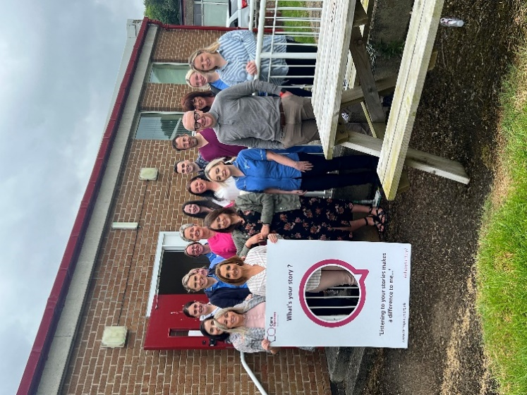
Your voice matters
‘Sharing your stories will help us to make it a better service for everyone’

If you would like more information, or if you wish to attend, please register your interest by contacting Dementia Navigator Stephanie Coyle on 07920087601

4.0 BRAIN HEALTH EVENT

5.0 JOBSTART SCHEME

The JobStart scheme provides funding from the Department for Communities to allow employers to create new job opportunities to help people aged 16-24 and 50-64 at risk of long-term unemployment to enter the job market.

JobStart 50+
The JobStart scheme has been extended to include people aged 50-64 who wish to enter or re-enter the workplace.

What do employers need to know about JobStart?
Employers in Northern Ireland can receive 100% government funding to create 6-month job opportunities for 16-24 and 50-64 year-olds without employment, education or training.
The closing dates for employer applications are:
- Sunday 30 June 2024 for opportunities for 16-24 year olds
- Sunday 21 July 2024 for opportunities for 50-64 year olds
Participants will be supported through their job opportunities by Work Coaches in the Department for Communities and the JobStart Team for those not in receipt of benefits.

Employer criteria to participate in JobStart
- Employers must be based in Northern Ireland.
- Employers of all sizes can participate in the scheme.
- Employers in all sectors can participate (including the voluntary and community sector).
- Employers can offer one job or multiple jobs to participate in JobStart (depending on the number of staff currently in permanent employment).
- JobStart opportunities must not replace existing or planned vacancies or cause existing employees, apprentices or contractors to lose or reduce their employment.
- Jobs offered must provide a 6-month job opportunity.
- Job opportunities must offer at least 25 hours of employment per week.
- Jobs offered must pay at least the National Minimum Wage (for the participant’s age group) through PAYE.
Please note: the Department for Communities will perform due diligence and financial checks on all employers. JobStart funding is available for employers.
For each job opportunity funding will cover:
- 100% of the relevant National Minimum Wage for 25 hours of work per week*
- the associated employer National Insurance contributions
- employer minimum automatic enrolment contributions
*Employers can offer additional hours but will have to fund the additional hours themselves
Please note: Employers will need to provide monthly payslips for each JobStart participant. Following approval of an individualised training plan, employers can avail of funding for each job opportunity to cover any support and training the participant may need. A support grant of £1,000 is available for 6-month opportunities.

How employers can participate in JobStart
Employers can apply for JobStart by completing an online application form.
https://www.communities-ni.gov.uk/JobStart
- Employers should allow 4 to 6 weeks for their application to be considered.
- Once an application has been approved, the Department will arrange for the opportunity to be advertised on JobApplyNI.com.
- Employers will follow their own recruitment process to select the best eligible candidate for the JobStart opportunity.

How people can participate in JobStart
Any person aged 16-24 or 50-64 years old in receipt of Universal Credit, Job Seekers Allowance, Income Support or Employment and Support Allowance can participate in the JobStart scheme if they are assessed as being work ready by a Work Coach from the Department for Communities.
Where a person is not currently claiming an eligible benefit, they should contact the JobStart & Work Experience Programme Branch in the Department for Communities on Tel 028 9072 6788 to check their eligibility and obtain information on how to apply for a JobStart scheme opportunity.

How employers can promote their participation in JobStart
Employers are free to promote their involvement in the scheme including through social media and on company websites.

Additional information
- Participants taking part in a JobStart opportunity will have the same statutory entitlements as other employees in the company in which they are employed.
- Employers will be required to put in place the statutory employer duties for the health, safety & welfare of participants, and pay National Insurance & Pension contributions.
- Employers must include support for participants to develop their occupational and employability skills to help them to reach their full potential.
- Employers will commit to providing the Department for Communities with timely, up-to-date and accurate information, as required.
- At the end of the job opportunity period, employers can consider retaining the participant(s).
- Alternatively, the participant will finish the job opportunity, having gained occupational and employability skills to help them find alternative employment or to progress into further education or training opportunities.

The Work Experience Programme
The Department for Communities also works with employers to offer short work experience placements ranging from 2-8 weeks for 16-65-year-olds or a fixed term placement of 13 weeks for 16-24-year-olds through the Work Experience Programme.

Further Information
For further information contact the Department for Communities JobStart & Work Experience Programme Branch
E-mail: jobstart.scheme@communities-ni.gov.uk
Telephone: 028 90726788

Employers can receive 100% government funding to create 6-month job opportunities for 16-24 and 50-64 year-olds without employment, education or training.

JobStart Scheme - employer guidance | Department for Communities (communities-ni.gov.uk)
JobStart Scheme | nidirect
JobStart | nibusinessinfo.co.uk

6.0 Vulnerability and Carbon Monoxide Allowance (VCMA) Annual Showcase

Thursday 18 July 2024, 9.30am-3.30pm (approx. timings)
As part of the Vulnerability and Carbon Monoxide Allowance (VCMA) delivery to support customers in vulnerable situations, the Gas Distribution Networks (GDNs) host an Annual VCMA Showcase event.
This online event provides the opportunity to gain insights into projects that they have funded during the past year, hear about their successes, challenges, and learnings, as well as looking ahead to the future.
The free event will take place online on Thursday 18 July 2024, 9.30am-3.30pm (approx. timings).
More details, including the agenda, will be sent out in the coming weeks. If you would like to reserve your place at this year’s event before receiving any additional details, you can register now via Eventbrite: https://www.eventbrite.co.uk/e/911254987197/?aff=oddtdtcreator
Please note by registering, your details will be shared with a third party (EQ Communications and the GDNs). If you have any questions please contact contact@vcmashowcase.co.uk.
The GDNs will be publishing their company specific and collaborative annual VCMA reports by the 1 July, giving stakeholders a chance to read and digest them before the showcase event.
Register Now

