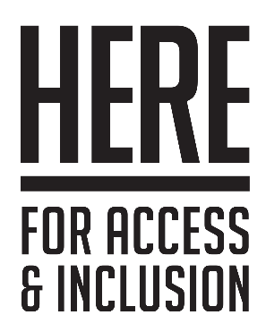
Access Rider

What is an Access Rider?
- An Access Rider is a document that details your individual access needs.
- An Access Rider can be used by anyone to make sure that any reasonable adjustments that they may need to perform a job are taken into consideration before you start the job.
- Using an Access Rider helps the individual and the organisation (like a gallery or events team) feel comfortable and sure about working together.
- Once you have completed your Access Rider, you can take it to any venues and organisations that you work with.

Who will see the information provided?
- Venue Name will share the information you provide with the people responsible for supporting and managing you in your role.
- We do not share this document with others without your permission.

There are 4 parts to the Access Rider:
- Your name, job/role, and contact information.
- Your access requirements relating to your job/role.
- Emergency Information - what we need to know about you in case of an emergency.
- Further information - any other relevant information you want to share.

Your personal Access Rider

Your information
- Name
- Job/Position
- Performance/Workshop Name
- Contact details

Your access requirements
- Here you can tell us about your access requirements and how we can help.
- You should only include details that have to do with your work.

Emergency information
- Use this section to tell us what to do and what not to do in an emergency.
- You can also provide an emergency contact person.

Further information
- Here you can provide any other information or resources you think will help us better understand you.

Additional Information:

University of Atypical is a disabled-led organisation that supports and promotes work by d/Deaf, disabled, and neurodivergent artists.
If you require more information, University of Atypical may be able to provide you with guidance, or direct you to further resources. You can learn more by visiting the University of Atypical website. University of Atypical

