DCSDC PEACEPLUS Local Co-Designed Action Plan – E Newsletter September 2024
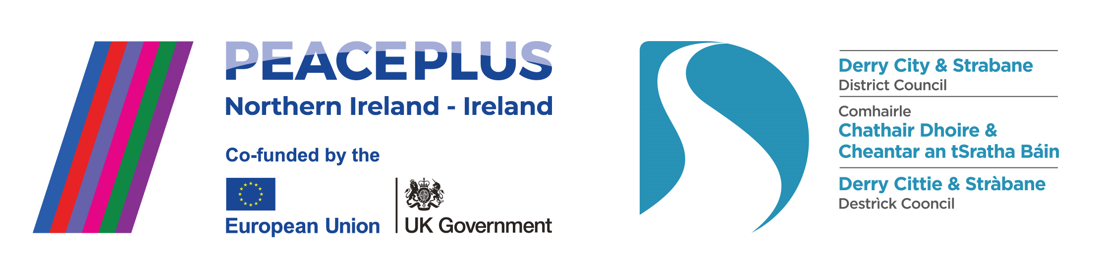

The PEACEPLUS Programme is a funding partnership between the European Union, the Governments of the United Kingdom and Ireland, and the Northern Ireland Executive and will be administered by the Special EU Programmes Body (SEUPB).

Celebrating the beginning of our local projects.

Autumn has arrived (with maybe a late blast of summer) and so has lift off for some of our earliest contracted projects in the photos below. The PEACEPLUS Board are delighted to see money hit the ground and people starting to benefit from project delivery. Between now and Christmas we’ll be tendering the remainder of our PEACEPLUS projects – so keep an eye out for those on eTendersNI if you are interested in applying.


A Stitch In Time Project Launch – Glen Development Initiative.

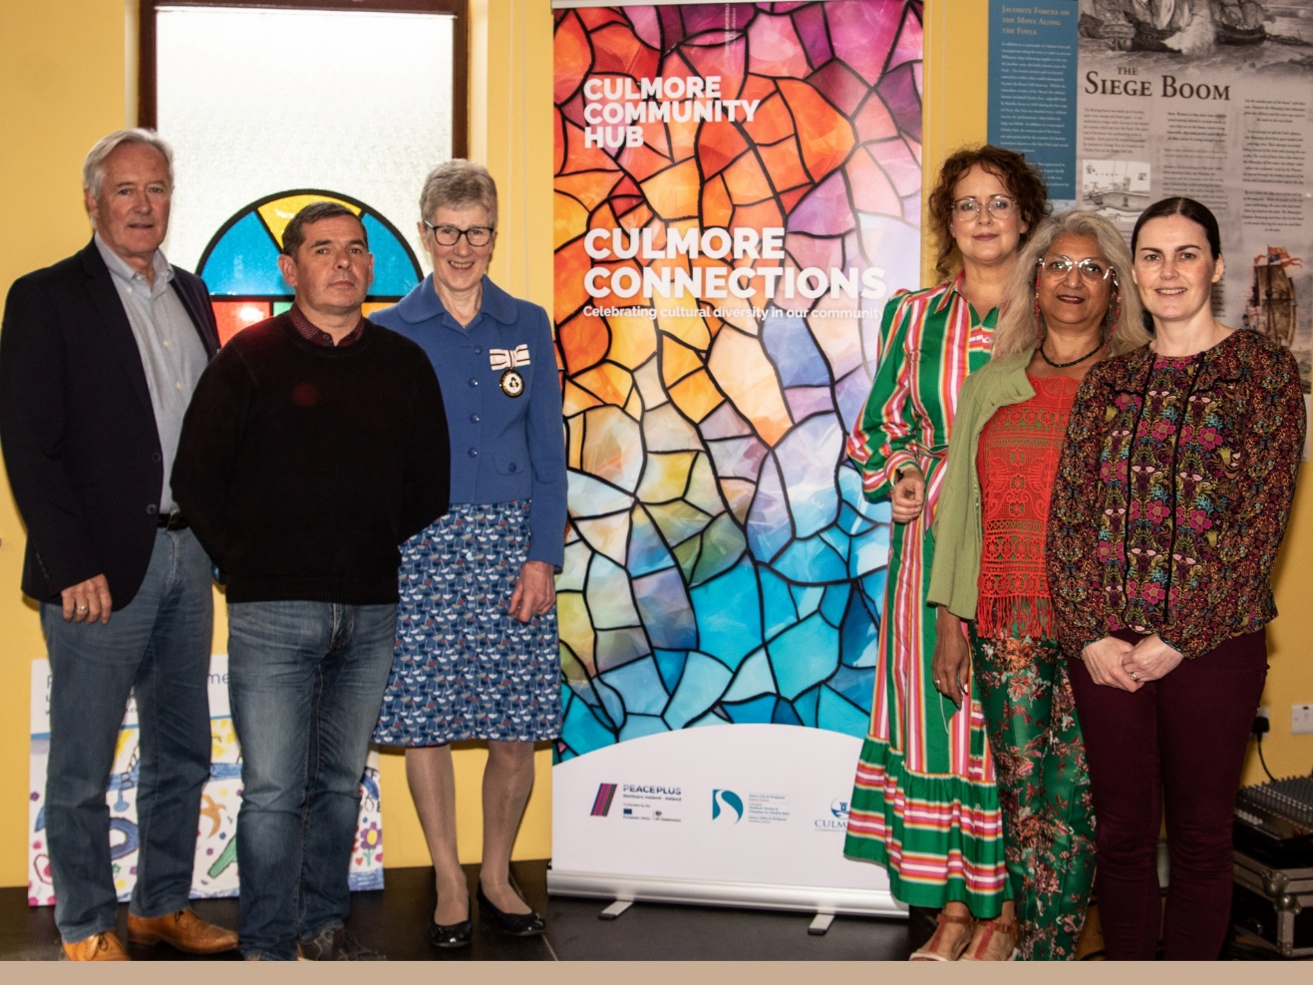
Culmore Connection Project – Culmore Community Hub.
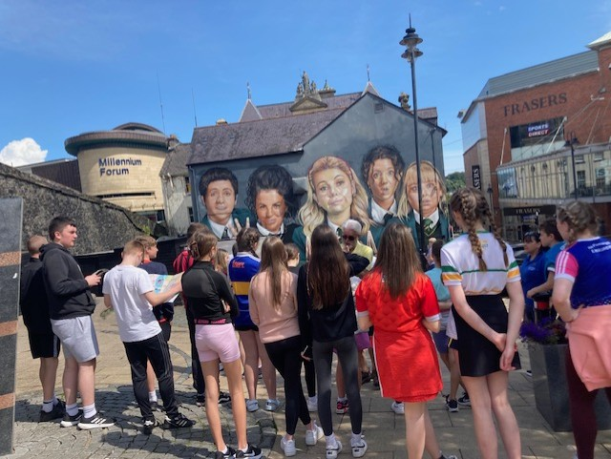
Our Space Our Place – Owenkillew Development Company.

Intercultural Café – North West Migrants Forum.

Current live tenders under DCSDC PEACEPLUS Local Co-Designed Action Plan:

Tender
T24-120BUS PEACEPLUS Street Art Reimaging
T24-152BUS PEACEPLUS Urban Social Farm (Reissue)
T24-155BUS PEACEPLUS Unlocking Silent Heritage (Reissue)
T24-123BUS PEACEPLUS Arts & Collaborative Resilience
T24-126BUS PEACEPLUS Reimage-Recycle
T24-128BUS PEACEPLUS Art: Recovery to Discovery
T24-124BUS PEACEPLUS Ballyarnett Early Years Project
T24-122BUS PEACEPLUS Be Driven
T24-121BUS PEACEPLUS Ballyarnett Women's Programme
T24-130BUS PEACEPLUS Our Present Past
T24-132BUS PEACEPLUS Distance Travelled
T24-131BUS PEACEPLUS Forward Thinking
T24-129BUS PEACEPLUS Fit for Purpose (Soccer)
T24-135BUS PEACEPLUS Cecil Frances Alexander Celebrated
T24-134BUS PEACEPLUS The Exodus Project
T24-125BUS PEACEPLUS Ballyarnett Men's Programme

For deadlines for returns, please see e-tenders NI website.

Council Website announcement: https://www.derrystrabane.com/business/tenders
All tenders are on E-Tenders NI: https://etendersni.gov.uk/epps/home.do
All our tenders are public procurement processes. Any organisations wishing to tender should do so via E-Tenders NI.

Want information on the projects / tender opportunities (including order of advertisement)?

Download a user-friendly version of our Local Co-Designed Action Plan Here:
https://www.derrystrabane.com/community/peace-plus/co-designed-action-plan

Download a more detailed project overview of the 58 included projects here:
https://www.derrystrabane.com/community/peace-plus/co-designed-action-plan

For email updates on tendering opportunities, see our website and make sure you’ve signed up to our email newsletter: https://www.derrystrabane.com/community/peace-plus

Don’t miss out on wider PEACEPLUS funding opportunities!
Remember, council doesn’t ‘run’ all of PEACEPLUS. Groups can apply directly to SEUPB.
Sign up to SEUPB’s emailing list here: https://seupb.us7.list-manage.com/subscribe

SEUPB €100,000 Small Grants Opportunity.
SEUPB have indicated they will issue a Small Grants Programme under Theme 1.2. Groups will be able to apply for up to €100,000. This is anticipated sometime in the Autumn. https://www.seupb.eu/PEACEPLUS

Grantfinder.
Check out other funding options on Grantfinder: https://search.mygrantfinder.co.uk/

Contact us:
The Peace Team in council can be reached via peace@derrystrabane.com
Our website is: https://www.derrystrabane.com/community/peace-plus

The PEACEPLUS Programme is a funding partnership between the European Union, the Governments of the United Kingdom and Ireland, and the Northern Ireland Executive and will be administered by the Special EU Programmes Body (SEUPB). Match-funding for this element of the PEACEPLUS Programme has been provided by the Executive Office in Northern Ireland and the Department of Housing, Planning, Community and Local Government in Ireland.

