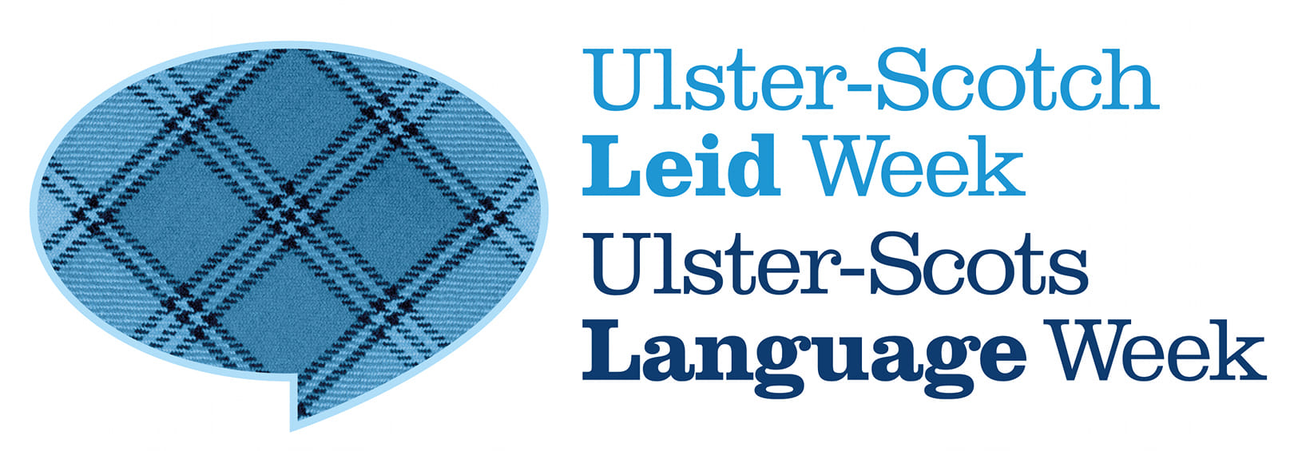

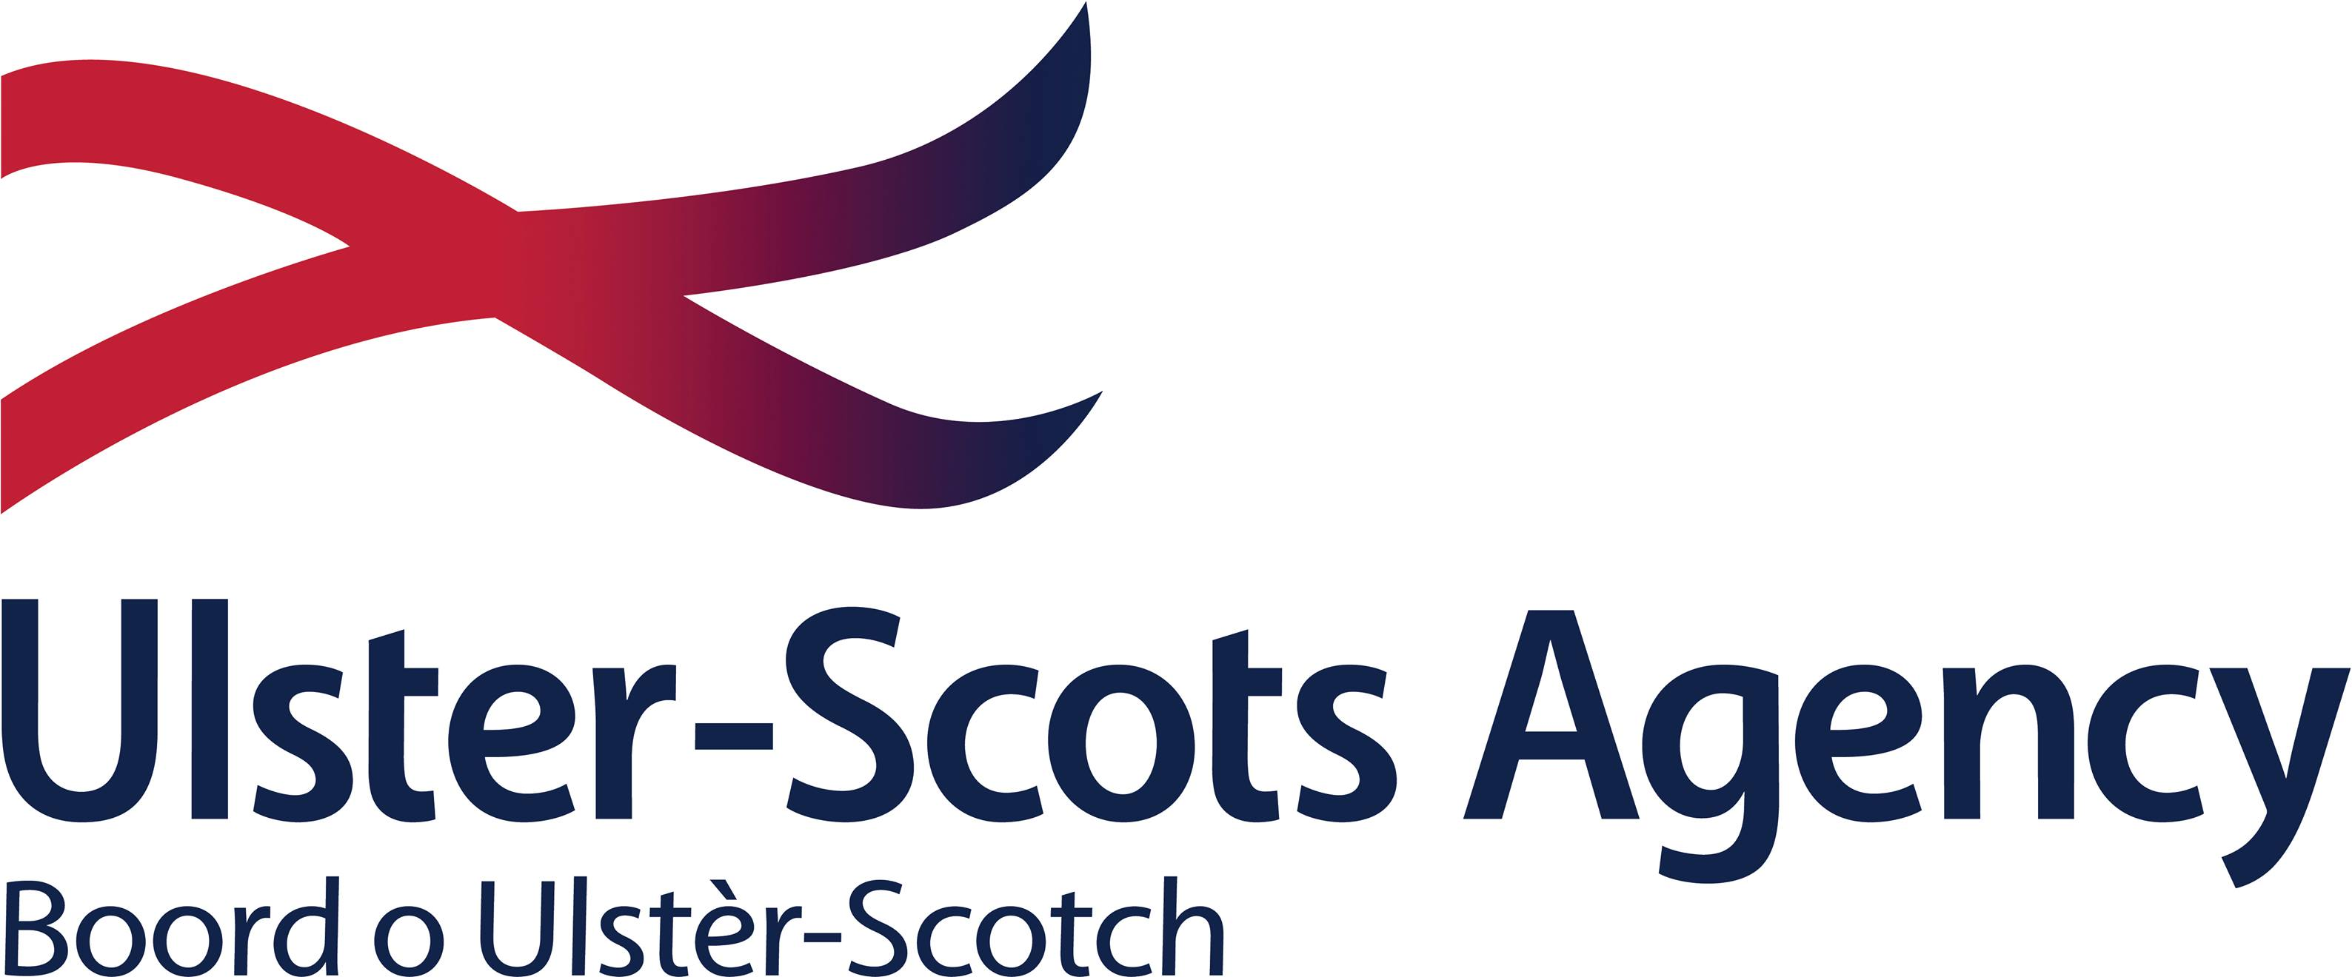

Kindly supported by the Ulster-Scots Agency

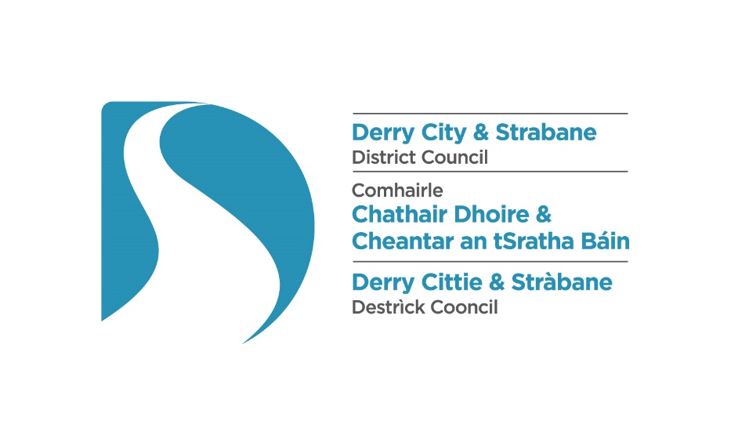

**Ulster-Scots Language Week 2024**

**Call for Proposals**

**Ulster-Scots Language Week 2024**

Derry City and Strabane District Council plans to mark Ulster-Scots Language Week 2024 (25-30 November) with a week-long programme of activity celebrating the unique contribution which the Ulster-Scots language makes to life in the city and district.

**Call for Proposals**

Council now invites proposals from suitably qualified individuals, groups or organisations, which outline ideas for projects, events or activities, which, if selected, will be included in our annual Ulster-Scots Language Week programme. The definition of ‘projects, events and activities’ will be interpreted in the broadest possible sense to provide opportunities for all types of proposals.

Applicants must be able to demonstrate that their proposal has the potential to: (a) promote and encourage greater awareness and understanding of the Ulster-Scots language, and; (b) engage audiences in creative and imaginative ways. All proposals must be able to demonstrate how the Ulster-Scots language is integral to the project.

Proposals may include, but are not limited to, the following types of activity:

* Ulster-Scots language learning and/or language awareness events/activities;
* language learning and educational resources, both digital and/or printed publications;
* projects which explore the Ulster-Scots literary tradition e.g. initiatives which explore the Ulster-Scots language within a particular geographical area, or which aim to raise awareness of the language in literature, music, song etc;
* musical or song-based events/projects which are predominantly language-focused;
* lectures, talks, or presentations in or about the Ulster-Scots language;
* drama and/or performance events/activities in or about the Ulster-Scots language;
* storytelling and/or poetry readings in or about the Ulster-Scots language;
* author or writer-led events which showcase the author’s original work in or about the Ulster-Scots language and/or which explore the Ulster-Scots literary tradition;
* creative writing events in or about the Ulster-Scots language;
* digital content, including audio, video, and/or multimedia content in or about the Ulster-Scots language which can be shared on the web, social media and other platforms;
* artwork which features or expounds the Ulster-Scots language and/or literary tradition.

**How to apply**

Applicants are invited to submit a proposal by completing the proposal form.

Applicants may apply for a maximum fee of £250.

Where applicable e.g. for in-person events, venue and catering costs will be covered by the Council. The applicant may be requested to deliver the event at a venue anywhere in the Derry City and Strabane District Council area.

For digital projects the applicant should provide detail of the proposed medium/media and format of the work.

**How we plan to score proposals**

Proposals will be scored using an 80% Quality and 20% Cost/Value for Money model. Appendix 1 provides more detail about how we plan to score applications.

Appendix 2 provides details of conditions associated with the award.

**Ulster-Scots Language Week 2024 – Proposal Form**

|  |  |
| --- | --- |
| **Applicant Name** |  |
| **Address** |  |
| **Telephone number** |  |
| **Email** |  |
| **Please provide details of any relevant qualifications and experience, or include a CV where appropriate** |  |
| **Please provide details of your proposed project, event or activity (80%)**  Provide details of the proposed project/event/activity demonstrating how the proposal relates to the aims of Ulster-Scots Language Week e.g. to promote greater awareness and understanding of the Ulster-Scots language; and/or to engage audiences in creative and imaginative ways. Please include details of the proposed format and duration of your project/event/activity, i.e. in-person, digital, publication, resource, artwork etc. and who the intended audience might be. Where appropriate, please include details of the proposed artist/presenter/speaker/facilitator if known. For in-person events, the applicant must be available to deliver the event in-person at a date to be agreed between 25 and 29 November 2024. Please indicate any dates/times on which you would be unavailable. Proposals for digital projects or e.g. artworks should detail the format(s)/medium in which the final work will be created. |  |
| **Costs/Value for Money (20%)**  Please provide a breakdown of the costs associated with your proposal. Total costs must not exceed £250 per application. |  |

**Deadline for Proposals**

Please submit your proposal via email to [ulsterscots@derrystrabane.com](mailto:ulsterscots@derrystrabane.com) by **Friday 20 September 2024 at 12 noon**.

Late or incomplete applications cannot be accepted.

**Appendix 1**

**How we plan to evaluate your proposal**

All proposals will be assessed against the quality and cost evaluation criteria below.

**Quality (80%)**

The following criteria and weightings will be applied to proposals.

|  |  |  |  |
| --- | --- | --- | --- |
| **Evaluation criteria** | **Criteria Weighting %** | **Details** | **Scoring** |
| Quality of Proposal | Marks (0-5) weighted x 16 | Language is integral to the project; the proposal demonstrates creativity and imagination; the proposal is relevant to the aims of Ulster-Scots Language Week e.g. promotes awareness and understanding of the language and has the potential to engage audiences.  Submissions will be scored between 0-5 using the marking matrix in the table below. | 80% |

**Marking Matrix**

|  |  |  |
| --- | --- | --- |
| **Band** | **Comments** |  |
|  |
| **5** | Fully detailed evidence provided, very minor concerns on detail, relevance or complexity |  |
| **4** | Detailed evidence provided, some concerns on detail, relevance or complexity |  |
| **3** | Reasonable evidence provided, lacking in detail, relevance or complexity |  |
| **2** | Limited evidence provided, significant concerns on detail, relevance or complexity |  |
| **1** | Little or no evidence provided, very significant concerns on detail, relevance or complexity |  |
| **0** | Failed to submit details or to address question |  |

If a proposal scores in band 0-3 it will be deemed that the application has not met the required quality threshold and is therefore ineligible.

**Cost**

|  |  |
| --- | --- |
| **Cost** | **20%** |
| Applicants may submit costs up to a maximum of £250.  Applicants should note that the Council is not obliged to accept the lowest-costed proposal or any submission. | The following formula will be used to evaluate Cost:   1. Lowest cost submitted will be awarded the maximum score available (20%); and; 2. To calculate the score for the costs submitted by the remaining proposals, the following formula will be applied – the lowest submitted cost divided by the proposer’s price, multiplied by the cost weighting (20%) |

**Final Score – combination of Quality (80%) and Cost (20%)**

Applicants who meet the quality threshold and who have submitted a price of £250 or below will be deemed appointable. The Council reserves the right to restrict or increase the number of successful proposals it selects as circumstances, requirements and/or funding dictate. Funding restrictions may mean that criteria may need to be enhanced. Appointments will be made on the basis of highest scoring proposals.

**Appendix 2**

**Conditions of Participation**

1. Derry City and Strabane District Council accepts no responsibility, financial or otherwise, for expenditure or liabilities arising out of the work of the recipient. Any commitment incurred in excess of the approved award shall be the responsibility of the applicant;
2. No aspect of the project being funded should be perceived as promoting any particular political viewpoint or religion (in intention, use, or presentation), or be likely to be perceived as discriminatory, or failing to afford equality of opportunity to the categories identified in Section 75 of the Northern Ireland Act 1998, namely, between persons of different religious belief; political opinion; racial or ethnic origin; age; marital status; sexual orientation; men and women generally; persons with disability and those without, and between persons with dependants and those without, or which may amount to a breach of the European Convention on Human Rights;
3. Award recipients must acknowledge, when publicising the content, that they are in receipt of financial support from Derry City and Strabane District Council and the Ulster-Scots Agency;
4. All projects must comply with all relevant statutory policies and procedures. If a project involves children, young people and/or adults at risk applicants must ensure that they adhere to best practice in relation to safeguarding and provide confirmation that they have all relevant safeguarding policies and procedures in place, with the ability to verify same upon request;
5. Events must be delivered in accordance with prevailing public health guidance and may be required to adapt to comply with such guidance;
6. The applicant must have sought all relevant permissions to use and/or present the content;
7. Derry City and Strabane District Council and the Ulster-Scots Agency reserve the right to make use of the content for the purposes of Ulster-Scots Language Week 2024 and for any related promotional purposes.

**If you have any questions or require clarification on any aspect of the proposal form or the application process please contact** [**ulsterscots@derrystrabane.com**](mailto:ulsterscots@derrystrabane.com)**.**