**DCSDC PEACEPLUS Local Co-Designed Action Plan – E Newsletter March 2025**

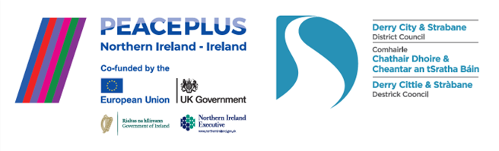

The PEACEPLUS Programme is a funding partnership between the European Union, the Governments of the United Kingdom and Ireland, and the Northern Ireland Executive and will be administered by the Special EU Programmes Body (SEUPB).

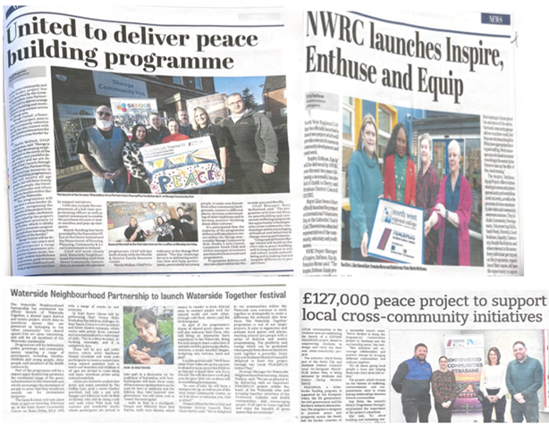

**Springing forward into delivering our Council’s PEACEPLUS Programme.**

Our local communities are springing into action with PEACEPLUS this new season. Over the last couple of months there have been so many project launches we’re beginning to lose track! Opportunities are now coming up thick and fast for groups and individuals to take part in the funded projects.

Are you an individual who wants to sign up and get involved? Whether you’re interested in upcycling furniture in the city area, turning community ideas into action in Strabane, or getting out and about in nature activities in the Faughan area, there is something in our programme for everyone. Email us on peace@derrystrabane and we’ll try to connect you with a project that interests you.

Are you involved in a community group and wanting some free activities to bring participants to? Again, contact us and we’ll try to sign post you to projects that will love to hear from you! We also have free opportunities for people to do OCN accredited community development training courses, so if you have volunteers or staff members who need a qualification, or know of people interested in getting involved in community work, contact us on [peace@derrystrabane.com](mailto:peace@derrystrabane.com)

**To get an idea of the projects we have on board, click here for our magazine:**

[**https://www.derrystrabane.com/community/peace-plus/co-designed-action-plan**](https://www.derrystrabane.com/community/peace-plus/co-designed-action-plan)

**INVITE: €40m PEACEPLUS - Change Maker Funding Programme**

The Special EU Programmes Body (SEUPB) and Pobal are currently preparing to open two new PEACEPLUS grants schemes aimed at grassroots communities. The Change Maker Funding Programme will distribute €40 Million over the next three years to support people to people projects on a cross community and/or cross-border basis.

Ahead of the schemes formally opening, a series of ‘Be Ready’ community information events are now scheduled for community, voluntary and target sector organisations who may be interested in applying over the next three years. Co-operation Ireland, in partnership with Rural Action and East Border Region will deliver these support events across the region. To find out about the small grants accessible under Investment Areas 1.2 and 6.2 of the PEACEPLUS Programme please register and come along:

**To register click on the community information event in your region to book to attend:**

**Derry City & Strabane District Council area**

**26th March - Londonderry/Derry: 11:00 am –** [New Gate Arts & Culture Centre, 2-4 Kennedy Place, Londonderry, BT48, 6RF](https://url.uk.m.mimecastprotect.com/s/3DVwCAPNpf9JKA8u2C6UG9P1k?domain=eventbrite.co.uk)

**Donegal County Council area**

**27th March - Termon: 7:00 pm -** [Craoibhin Community Enterprise Centre, Currin, Termon, Letterkenny Co. Donegal F92 TY09](https://url.uk.m.mimecastprotect.com/s/vBKOCBLNqSVJX5yCrFRU2O-tK?domain=eventbrite.co.uk)

Please note – your local council and the DCSDC PEACE Team are NOT the lead on these grants, we are simply promoting the information.

**Celebrating recent project launches!**

**‘Out and About’ Project** – Delivered by Waterside Neighbourhood Partnership in partnership with Fuse Arts, this District Wide project will deliver a range of local awareness bus trips, residentials and activities. It aims to engage members of our local Black and Minority Ethnic communities – particularly those with voluntary run community groups.

**The Skeoge United project**, under our Community Regeneration and Transformation Theme, is delivered by the Greater Shantallow Area Partnership. It includes purchase of a minibus and marquees to link spaces and cross-community programming in the area.

**Reimage-Recycle** in the Foyleside area will have a soft-skills environmental focus on recycling, upcycling and zero-waste. It will engage Men’s and Hen’s sheds and equality / section 75 groups as well as any interested individuals. It will be delivered by Glen Development Initiative.

**Empowered Communities Strabane** is a networking and empowerment programme for the Strabane area to build joint decision making and cross-community and cross-border work. It will be delivered by Strabane and District Caring Services.

**Be Wild** is an equine and nature assisted learning project for children and their parents along with wider outdoor and environmental family opportunities in the Faughan area. It will be delivered by Gortilea Social Farm.

**Grantfinder.**

Check out other funding options on Grantfinder: <https://search.mygrantfinder.co.uk/>

**Contact us:**

The PEACE Team in council can be reached via [peace@derrystrabane.com](mailto:peace@derrystrabane.com)

Our website is: <https://www.derrystrabane.com/community/peace-plus>

The PEACEPLUS Programme is a funding partnership between the European Union, the Governments of the United Kingdom and Ireland, and the Northern Ireland Executive and will be administered by the Special EU Programmes Body (SEUPB). Match-funding for this element of the PEACEPLUS Programme has been provided by the Executive Office in Northern Ireland and the Department of Housing, Planning, Community and Local Government in Ireland.