DCSDC PEACEPLUS Local Co-Designed Action Plan – E Newsletter January 2025
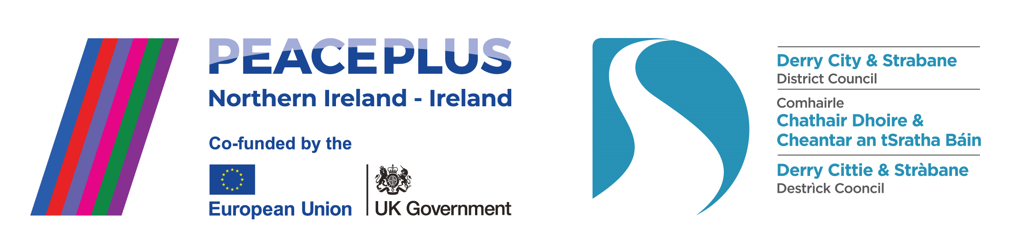
The PEACEPLUS Programme is a funding partnership between the European Union, the Governments of the United Kingdom and Ireland, and the Northern Ireland Executive and will be administered by the Special EU Programmes Body (SEUPB).


New Year, New Opportunities: SEUPB PEACEPLUS ‘Change Makers’ Small Grants.

While the procurement phase of our local council-led PEACEPLUS programme is almost complete, communities should keep their eyes peeled for the new ‘Change Makers’ Small Grants Programme under a different part of PEACEPLUS. These are opening very soon. Initial information is available here: Change Makers Funds | SEUPB

The Change Makers Funds will distribute €40m over the next three years to support people to people projects on a cross community and/or cross-border basis, delivering awards of up to €100,000 directly into communities.

These will be for projects which link and bring together people. They don’t include capital works or vehicles etc. Groups applying will need to link with at least one other group which brings balance to make their participant grouping either cross-border and/or cross-community. The Change Makers Funds will focus on activities which enhance community cohesion and bring communities and groups together on a cross community (Investment Area 1.2) or Cross Border (Investment Area 6.2) basis, with the aim of embedding and enhancing existing relationships, and establishing new relationships and networks.

The funds are available to community and voluntary groups and other organisations– and are flexible in the activity that they deliver, but all projects must have a strong focus on improving cross community and cross-border relationships.

Please note – your local council and the DCSDC PEACE Team are NOT the lead on these grants, we are simply promoting the information. Co-operation Ireland, in partnership with Rural Action and East Border Region, have been contracted to help promote the programme and support groups to apply. It is our understanding that they intend to roll out information workshops in the coming weeks. Keep your eyes open and make the most of the opportunity.

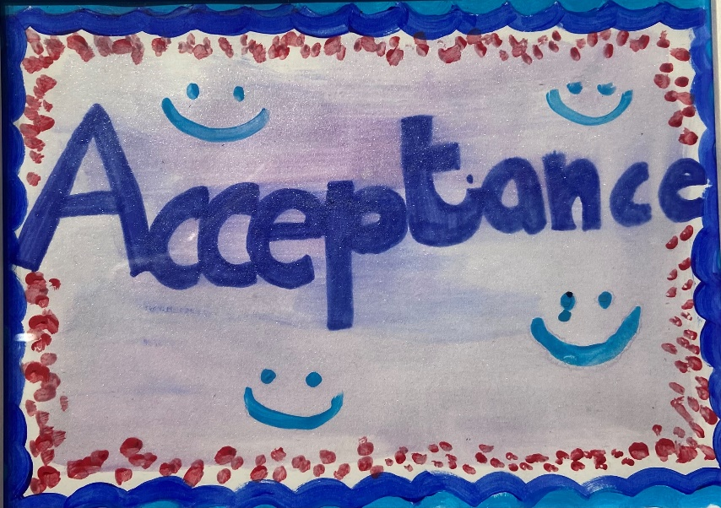

Current live tenders under DCSDC PEACEPLUS Local Co-Designed Action Plan:

Tender | Deadline
T24-213BUS PEACEPLUS Distance Travelled (Reissue) | 29th January 2025
T25-009BUS PEACEPLUS Ballyarnett Early Years Project (Re-issue) | February 25 – see e-tenders NI.
T25-008BUS PEACEPLUS Ballyarnett Women’s Programme (Re-issue) | February 25 – see e-tenders NI.

For exact deadlines for returns, please see e-tenders NI website.
Council Website announcement: https://www.derrystrabane.com/business/tenders
All tenders are on E-Tenders NI: https://etendersni.gov.uk/epps/home.do
All our tenders are public procurement processes. Any organisations wishing to tender should do so via E-Tenders NI.

Celebrating recent project launches!

Culture Now Showcase - Delivered by North West Cultural Partnership, this District wide project is under the Celebrating Cultural Diversity (CCD) Theme. It will deliver a headline performance showcase incorporating ulster-Scots, British and Irish cultures alongside other diverse contemporary cultures.
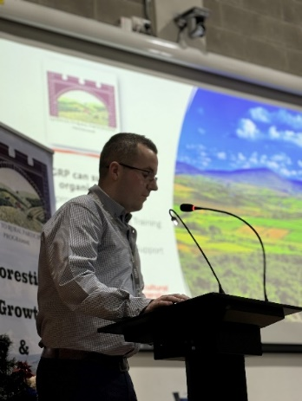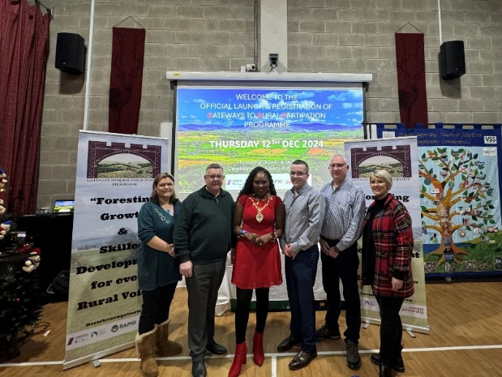
Gateways to Rural Participation – Delivered by the North West Cultural Partnership, working also with RAPID (Rural Area partnership Derry), this rural capacity building and leadership project will work with 15 groups from very diverse identities.
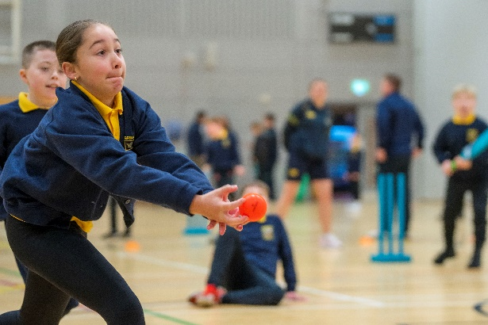

Cricket Connects – The NW Cricket Union are delivering a really unique intergenerational cricket PEACEPLUS project, bringing cricket to non-traditional cricket communities through street cricket, capacity building and networking.
Funding Alert! Department of Foreign Affairs - Reconciliation Fund

If you’re looking for another avenue for peace and reconciliation funding, why not check out this one too? The DFA’s Reconciliation Fund’s Annual Funding Round (for 12-month funding) will open on Wednesday, 12th February 2025 at 11am. Applications via the online application portal. Deadline 19th March 2025 at 12pm. This funding is only open once a year.

For information on current funding criteria and priorities that guide how grants are awarded by the Reconciliation Fund, see here (in pdf format). In addition to project funding, the Reconciliation Fund will welcome applications for core operational as well as certain capital costs, where this will support organisations’ work within the framework of the strategy. Full details on how to apply are on their website: www.dfa.ie/reconciliation.

If you have any queries on this funding stream, contact reconciliation@dfa.ie.
There is also a funding workshop you can register for:
Derry – Wednesday, 5 February 2025 – Afternoon. Click here to register:
Reconciliation Fund Outreach Workshop Derry 5 February 2025 at 14:00 | Eventbrite

Download a user-friendly version of the PEACEPLUS Local Co-Designed Action Plan Here:
https://www.derrystrabane.com/community/peace-plus/co-designed-action-plan

Grantfinder.
Check out other funding options on Grantfinder: https://search.mygrantfinder.co.uk/

Contact us:
The PEACE Team in council can be reached via peace@derrystrabane.com
Our website is: https://www.derrystrabane.com/community/peace-plus

The PEACEPLUS Programme is a funding partnership between the European Union, the Governments of the United Kingdom and Ireland, and the Northern Ireland Executive and will be administered by the Special EU Programmes Body (SEUPB). Match-funding for this element of the PEACEPLUS Programme has been provided by the Executive Office in Northern Ireland and the Department of Housing, Planning, Community and Local Government in Ireland.

