DCSDC PEACEPLUS Local Co-Designed Action Plan – E Newsletter April 2024
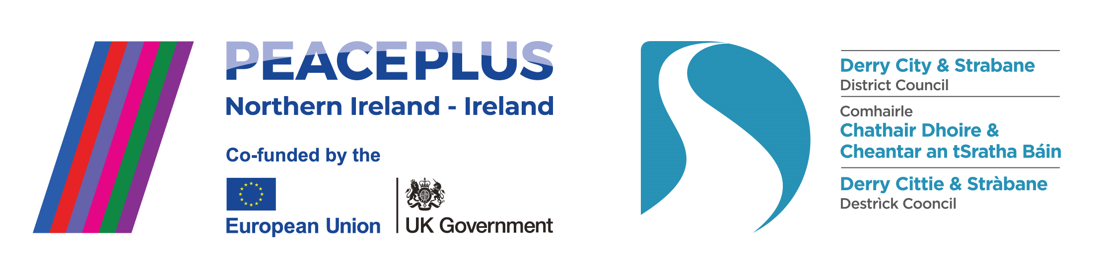

The PEACEPLUS Programme is a funding partnership between the European Union, the Governments of the United Kingdom and Ireland, and the Northern Ireland Executive and will be administered by the Special EU Programmes Body (SEUPB).

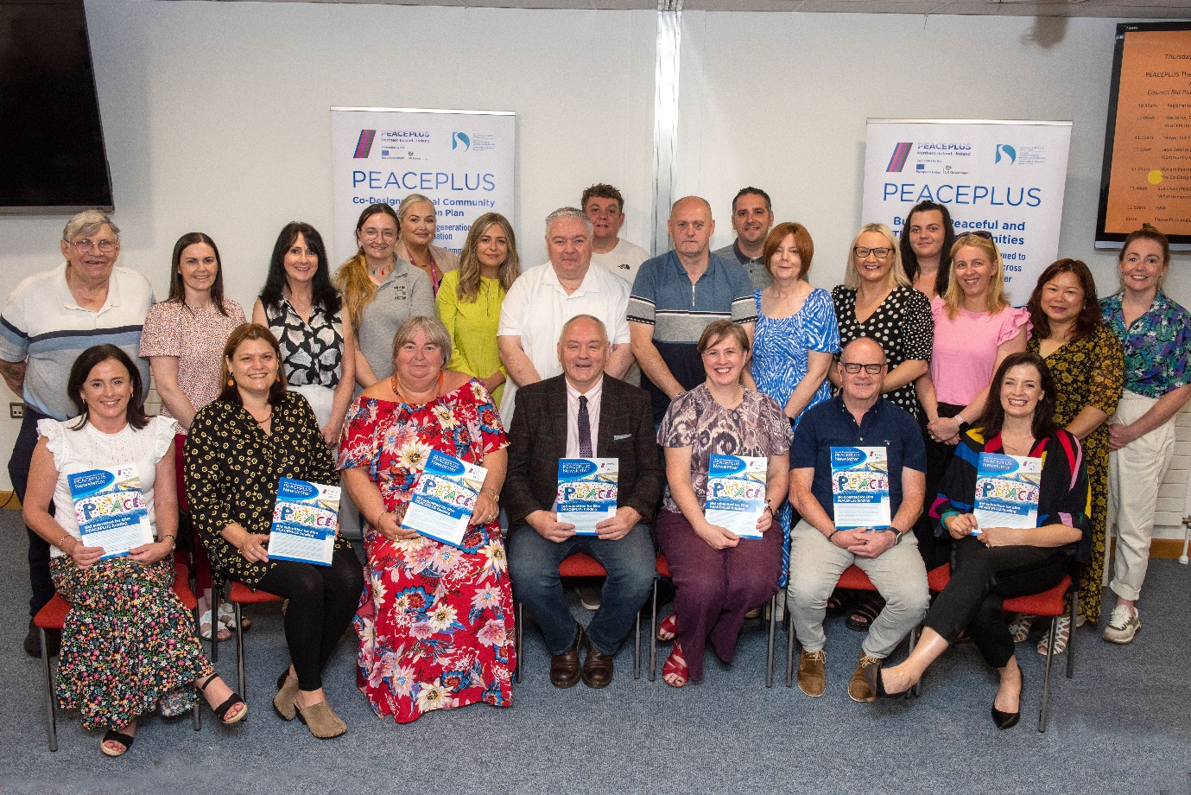

£8 million funding secured for Derry and Strabane Council PEACEPLUS Theme 1.1 bid.

Derry City and Strabane District Council and the PEACEPLUS Partnership Board are celebrating being the first Council in Northern Ireland to secure funding under PEACEPLUS. The Local Co-Designed Action Plan has successfully secured £8,047,327 which will fund 58 council area projects.

Mayor of Derry City and Strabane District Council Cllr Patricia Logue welcoming the news today said: “Reaching this point has been the culmination of a long process working with, listening to, and empowering local communities across the entire geography of our city and district. It has involved designing, costing and detailing 58 projects under three themes – Community Regeneration and Transformation, Thriving and Peaceful Communities, and Celebrating Cultural Diversity. Congratulations to everyone involved and for the dedication and team effort throughout this process.”

Catherine Cooke (Foyle Women’s Information Network / Chair of the PEACEPLUS Board.) said: “We’re thrilled at the announcement. Getting to this stage has taken huge commitment and partnership working between the local community and voluntary sector, the Local Growth Partnerships, council and statutory agencies. The Board are thankful for the momentous energy and patience invested by everyone engaged in that process. The 58 projects will be tendered and will pour much needed funding into local communities.

Martin Duffy (Derg Local Growth Partnership / Co-Chair of the PEACEPLUS Board) added: “This welcome announcement marks a key milestone for our council area,’ said ‘The funding will make a significant difference to cross-community engagement, peace and reconciliation and meeting key needs articulated by the community sector in the co-design phase of the bid.”

Sue Divin is Derry City and Strabane District Council’ s PEACE Manager. She explained the significance of the announcement. “The funding is under a specific part of the PEACEPLUS Programme for local councils to bid for. We will be encouraging local community groups to look at the opportunities and tender to win the contracts. We will also be highlighting how there are 21 other parts of the PEACEPLUS programme, including Theme 1.2 Small Grants opportunities up to €100,000. Further information is expected to be issued by SEUPB on those in the next few months, so interested groups should watch for those opportunities on the SEUPB website. We would strongly encourage groups from our Council area to apply to maximize the benefit from PEACEPLUS funding together.”

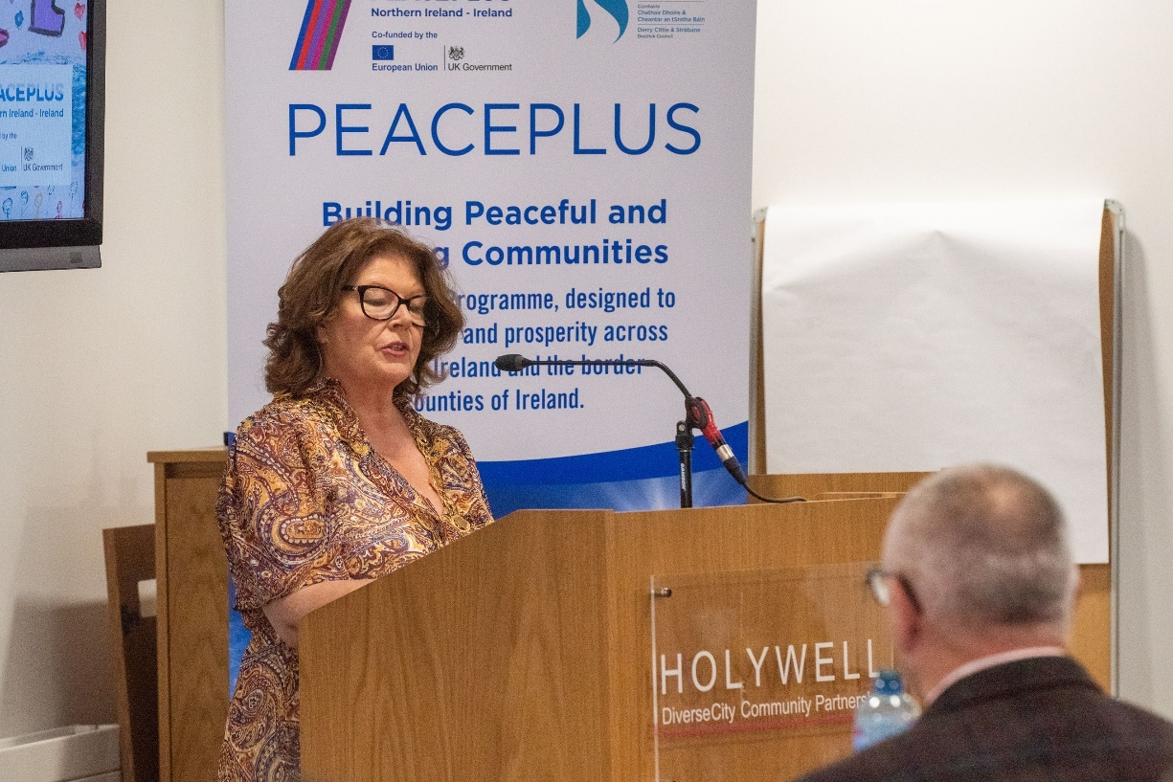

Current live tenders under DCSDC PEACEPLUS Local Co-Designed Action Plan:

Tender | Deadline for Returns
T24-013BUS PEACEPLUS Theme 1.1 Empowered Communities Strabane | 26th April 24
T24-014BUS PEACEPLUS Theme 1.1 Creating Creatives | 26th April 24
T24-015BUS PEACEPLUS Theme 1.1 Strabane Youth Programme | 26th April 24
T24-016BUS PEACEPLUS Theme 1.1 Our Place, Our Planet | 26th April 24
T24–071BUS PEACEPLUS Food Poverty Project | 3rd May 24
T24-044BUS PEACEPLUS Theme 1.1 Farming and Environmental Champions | 17th May 24
T24-046BUS PEACEPLUS Theme 1.1 Connect Project (BAME) | 17th May 24
T24-047BUS PEACEPLUS Muintearas (Belonging) | 17th May 24
T24-074BUS PEACEPLUS Derg Future Festivals | 17th May 24

Council Website announcement: https://www.derrystrabane.com/business/tenders
All tenders are on E-Tenders NI: https://etendersni.gov.uk/epps/home.do
This is a public procurement process. Any organisations wishing to tender should do so via E-Tenders NI.

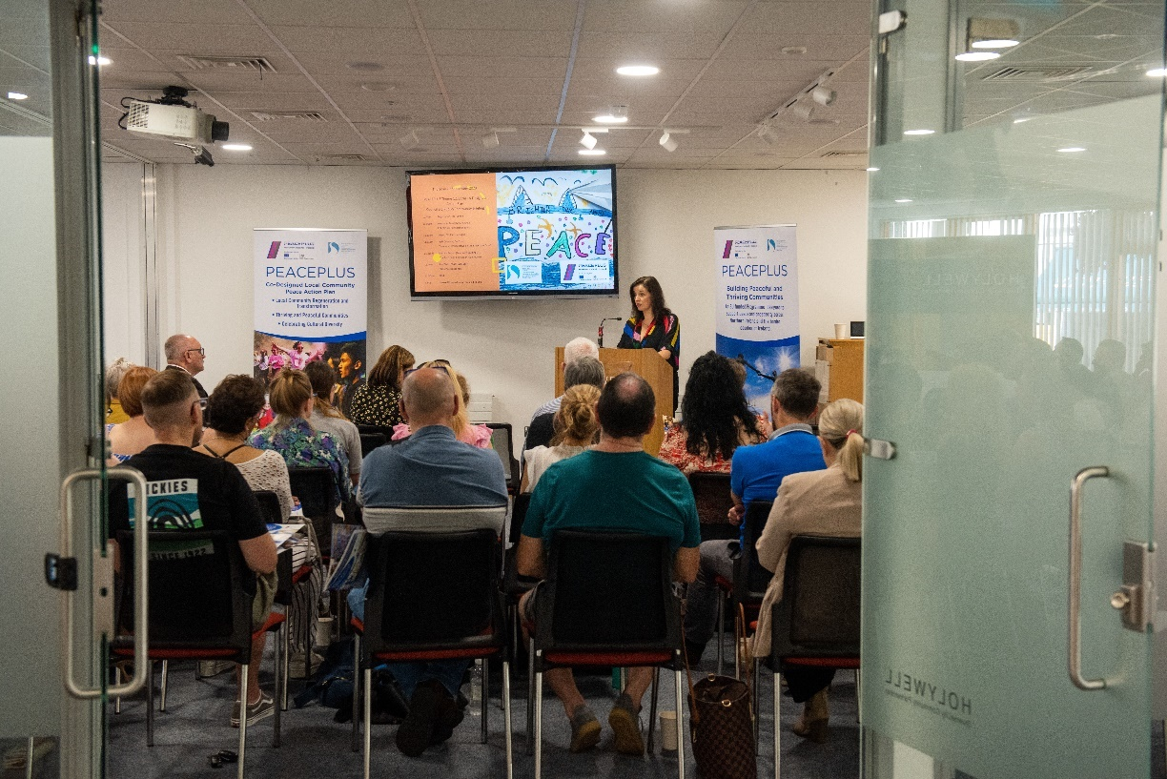

Reserve your place on our public/community Tender Training workshops.

Our Tender Training workshops are proving highly popular for community and voluntary sector organisations interested in tendering for one or more of our 58 PEACEPLUS project contracts.

If your organization is new to tendering, or if you feel you would benefit from this training, register – groups are finding it extremely useful. It is fine for organizations to reserve more than one place (or attend a repeat workshop) and training is relevant to anyone who may directly work on writing and submitting a tender. Recordings will not be available. The session below may be our final session until the autumn.

Sign up and info on:

Link: https://www.eventbrite.co.uk/e/845906668617

Venue: Learmount Resource Centre (Park Village, Near Claudy)
Date: Wednesday 24th April 2024 10.00am – 12.30pm (Tea/Coffee from 9.45am)

Useful steps you could take now are:

- Register on E-tenders NI: All our tenders will be advertised on E-tenders NI. If your organization is not already registered, you can do so here: European Dynamics - Welcome to eTendersNI
- E-tenders Updates: On E-tenders, select to have automatic updates from DCSD Council. All our PEACEPLUS Tenders will fall into CPV Code 85322000 Community Action Programme. Registering for these alerts will mean you won’t miss our tenders.

PEACEPLUS Investment Area 1.3- Building Positive Relations. Open! Deadline 13th June.

For your information, SEUPB have opened their funding for PEACEPLUS major regional projects. Please note this is different to their small grants programme which has not yet opened. This call is open to larger community and voluntary sector organisations (and other organisations) who can work ‘beyond local boundaries’.

As we are a cross-border area with good community and voluntary sector capacity it would be great to see local organisations bidding for funding with regional ideas. This is likely to mean partnering with other organisations across Northern Ireland and the border counties. Council does not run these processes – the funder is SEUPB and organisations need to apply via the portal on the SEUPB website.
Applications are invited for projects which will promote good relations characterised by respect, where cultural diversity is celebrated and people can live, learn and socialise together, free from prejudice, hate and intolerance. Supported projects will enable individuals and communities to collaborate across a broad range of areas of mutual interest, such as parenting, arts and culture, sport, education, and social innovation/enterprise.
The programme area aims to increase in the percentage of the programme area population which has relationships with and as such a greater understanding of those from different cultural backgrounds.
The call will be open for 12 weeks, with a closing date of 13th June 2024. Pre-application support for potential applicants is available on the SEUPB website, along with the call document. More information and details on how to apply can be found below:
https://www.seupb.eu/peaceplus/overview/themes-and-investment-areas/theme-1/13-building-positive-relations/investment

Want information on the projects / tender opportunities (including order of advertisement)?

Download a user-friendly version of our Local Co-Designed Action Plan Here:
https://www.derrystrabane.com/community/peace-plus/co-designed-action-plan

Download a more detailed project overview of the 58 included projects here:
https://www.derrystrabane.com/community/peace-plus/co-designed-action-plan

For email updates on tendering opportunities, see our website and make sure you’ve signed up to our email newsletter: https://www.derrystrabane.com/community/peace-plus

Don’t miss out on wider PEACEPLUS funding opportunities!
Remember, council doesn’t ‘run’ all of PEACEPLUS. Groups can apply directly to SEUPB.
Sign up to SEUPB’s emailing list here: https://seupb.us7.list-manage.com/subscribe

SEUPB €100,000 Small Grants Opportunity.
SEUPB have indicated they will issue a Small Grants Programme under Theme 1.2. Groups will be able to apply for up to €100,000. Get thinking ahead! https://www.seupb.eu/PEACEPLUS

Grantfinder.
Check out other funding options on Grantfinder: https://search.mygrantfinder.co.uk/

Contact us:
The Peace Team in council can be reached via peace@derrystrabane.com
Our website is: https://www.derrystrabane.com/community/peace-plus

The PEACEPLUS Programme is a funding partnership between the European Union, the Governments of the United Kingdom and Ireland, and the Northern Ireland Executive and will be administered by the Special EU Programmes Body (SEUPB). Match-funding for this element of the PEACEPLUS Programme has been provided by the Executive Office in Northern Ireland and the Department of Housing, Planning, Community and Local Government in Ireland.

